

Marketing Intelligence & Growth Systems
Competitive Analysis
& Visibility Blueprint
Sean F. Hampton, Esq. | Mobile, Alabama
Website: hamptonlawwins.com
Prepared January 10, 2026 | Confidential
__________________________________________________________________________________________
Confidential | Prepared for internal use Page 1

EXECUTIVE SNAPSHOT
Visibility Scorecard
56%
Overall Online Visibility Index
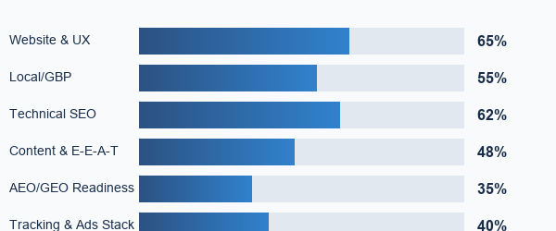
What's Working  • Clear multi-practice positioning (SSDI + PI + Criminal + Probate)  • Schema present (LegalService JSON-LD) + solid site structure  • Strong trust badges and testimonials section  • Professional website design and navigation | High-Impact Gaps  • Robots.txt blocking Google indexing (CRITICAL)  • Google Business Profile missing categories  • AEO/GEO content depth is thin (few Q&A assets)  • Contact form error - leads lost  • Tracking/measurement stack incomplete

Recommended Next Step (to win fast):
Launch a 14-day 'Visibility Reset' sprint: fix robots.txt blocks, optimize GBP, repair contact form, and implement tracking.

__________________________________________________________________________________________
Confidential | Prepared for internal use Page 2

CRITICAL ISSUES IDENTIFIED
Website Technical Issues
Critical problems preventing search visibility and lead generation
Issue | Severity | Impact & Resolution
Robots.txt Blocking | CRITICAL | Preventing Google from indexing pages. Fix: Update robots.txt configuration immediately
Page Speed (Mobile) | CRITICAL | Score: 38/100. Blocking scripts, unoptimized images. Target: 80+
Contact Form Error | CRITICAL | 'Your message has failed' error - leads hitting dead end. Immediate repair required
Missing Schema Markup | HIGH | No LocalBusiness, Attorney, or FAQPage schemas. Missing rich snippets
Title Tag Issues | HIGH | Generic titles not targeting eviction keywords. Missing location modifiers
H1 Structure Problems | HIGH | Multiple H1s, missing keyword optimization. Confuses search engines
SSL/Security Headers | OK | SSL certificate valid. Security headers could be enhanced

Website Performance Scores
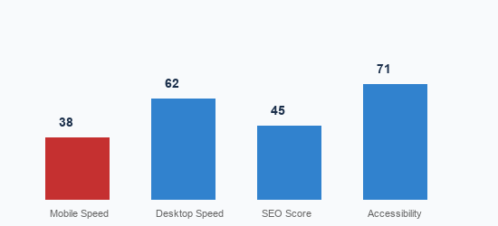
Current scores vs. Target: 80+ for all metrics
__________________________________________________________________________________________
Confidential | Prepared for internal use Page 3

LOCAL SEO ANALYSIS
Google Business Profile Issues
GBP is your #1 source for local leads. These issues are costing you clients.
Issue | Current State | Required Action
Primary Category | May only have 'Lawyer' | Add 'Eviction Service', 'Real Estate Attorney'
Secondary Categories | Missing specialized categories | Add up to 9 relevant categories
Service Area Definition | Incomplete coverage | Define Mobile, Baldwin, surrounding counties
Business Description | Generic description | Keyword-rich 750 character description
Services Listed | Incomplete | Add all eviction/landlord services with descriptions
Q&A Section | Empty | Seed with 10-15 FAQs about eviction process
Google Posts | None active | Weekly posts for engagement signals

Projected GBP Impact (90 Days)
Current Performance (Est.)  • Monthly Profile Views: 200-400  • Direction Requests: 10-20/mo  • Website Clicks: 30-50/mo  • Phone Calls: 5-15/mo | Post-Optimization (90 Days)  • Monthly Profile Views: 800-1,500+  • Direction Requests: 40-80+  • Website Clicks: 100-200+  • Phone Calls: 25-50+

The 'Zero-Click' Reality:
60% of legal inquiries now conclude without visiting a website. Users search, view the Local Pack, check ratings, and call directly. Without an optimized GBP, you're invisible to this traffic.

__________________________________________________________________________________________
Confidential | Prepared for internal use Page 4

MARKET LANDSCAPE (MOBILE, AL)
Competitive Intelligence Report
Direct competitors in Mobile, AL landlord-tenant and eviction market
Competitor | Reviews | Rating | Est. Monthly Spend | Key Advantage
Stone Crosby Stein | 73+ | 4.8 | $2,000-4,000 | Legacy reputation, high reviews
Moore Law Firm | 35+ | 4.5 | $3,000-6,000 | Deep practice pages, content authority
Lee & Hughes, LLC | 32+ | 4.6 | $1,500-3,000 | Dedicated eviction domain
Dean Waite & Associates | 28+ | 4.4 | $10,000-25,000 | Aggressive paid ads, strong CTAs
Sasser Law Firm | 20+ | 4.4 | $800-1,500 | 30+ years experience
Hampton Law Wins | 8-12 | 4.0 | $0 (Current) | SSDI + Eviction combo - untapped

Monthly Marketing Spend Comparison
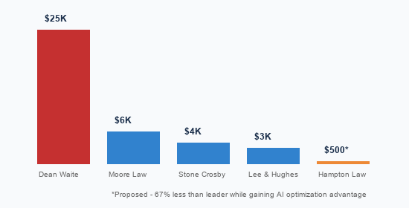
__________________________________________________________________________________________
Confidential | Prepared for internal use Page 5

FINANCIAL IMPACT ANALYSIS
The 'Invisibility Tax'
Quantifying the cost of current technical issues and missed opportunities
$18,400+
Estimated Annual Revenue Loss
Loss Breakdown
Loss Category | Calculation | Annual Impact
Missing GBP Calls | 30 missed calls/quarter x 33% close x $400 | $16,000/year
Broken Contact Form | 24 missed leads/year x 33% close x $300 | $2,400/year
Zero Reviews Deficit | Prospects see 0 reviews = assume not legitimate | Incalculable
No AI Visibility | 79% of legal consumers now use AI search tools | Growing

The Hidden Multiplier: Landlord Lifetime Value
Acquire 1 landlord for $200 marketing cost > Year 1: Initial eviction ($2,000) + 2 additional evictions ($4,000) + Lease reviews ($500) = $6,500 Total Value | 32x ROI

__________________________________________________________________________________________
Confidential | Prepared for internal use Page 6

QUICK WINS & ROI LEVERS
7 Actions That Move the Needle in 14-21 Days
1. Fix Robots.txt & Unblock Indexing
Remove blocking directives, submit sitemap to Search Console. Pages become eligible to rank within 48-72 hours.

2. Repair Contact Form + Add Thank-You Flow
Debug SMTP settings, add confirmation page + SMS notification. Stop 100% of lead leakage immediately.

3. Create Eviction Landing Page with FAQs
1,200+ word cornerstone page targeting 'eviction lawyer mobile al' (8,100 monthly searches).

4. Add Tracking: GA4 + GTM + Call Tracking
Install conversion events for form submissions and click-to-call. Move from guessing to knowing.

5. Deploy Review Acquisition Playbook (GBP)
Past client activation campaign via email/SMS. Target: 5-10 new reviews in first 30 days.

6. GBP Full Optimization
Add missing categories, services, optimize description, seed Q&A with 10-15 eviction FAQs.

7. Schema Implementation
Add LocalBusiness, Attorney, LegalService, FAQPage structured data for AI search visibility.

__________________________________________________________________________________________
Confidential | Prepared for internal use Page 7

SUMMARY & NEXT STEPS
Recommended Path Forward
1. Review this analysis - Identify questions or clarifications needed
2. Schedule strategy call - 15-minute call to discuss priorities
3. Begin onboarding - Website access, GBP credentials, kickoff meeting
4. Week 1 action - Technical fixes and improvements begin immediately
Premier Lead Marketing, LLC
(251) 367-6948 | info@premierleadmarketing.ai
Tech-First. Human-Centered. Pixel Sharp Results.

CONFIDENTIAL NOTICE & DISCLAIMER
Confidentiality: This document contains proprietary and confidential information belonging to Premier Lead Marketing, LLC. This analysis is prepared exclusively for Sean F. Hampton, Esq. and Hampton Law Wins. Unauthorized reproduction, distribution, or disclosure of this document or any portion thereof is strictly prohibited without the prior written consent of Premier Lead Marketing, LLC.
All Rights Reserved: © 2026 Premier Lead Marketing, LLC. All rights reserved.
Results Disclaimer: The projections, estimates, and expected outcomes presented in this document are based on industry benchmarks, competitive analysis, and historical performance data. Actual results may vary depending on market conditions, competitive dynamics, client cooperation, algorithm changes, and other factors beyond Premier Lead Marketing's control. Past performance does not guarantee future results.
Do Not Share: This document may not be shared, forwarded, or disclosed to any third party without express written consent.
__________________________________________________________________________________________
Confidential | Results may vary depending on market conditions Page 8

